Welcome
Trinity Lutheran Church
Lutheran Church—Missouri Synod
A Stephen Ministry Congregation

1354 South Otsego Avenue
Gaylord, Michigan 49735
Church Phone: (989) 732-4816

Church Email: secretary@trinitygaylord.com
www.trinitygaylord.com

Office Hours: Monday through Friday 9am – 1pm

OUR PURPOSE
…is to LOVE GOD, LOVE OTHERS, AND SERVE THE WORLD by worshiping the Lord Jesus, bringing our members into Christ-like maturity, and equipping them through Word and Sacrament for their mission and ministry. We go heart to heart into the world with Jesus, sharing His love, caring for one another, praying, and bringing the lost into a relationship with Christ, by the working of the Holy Spirit.

January 9, 2022
Baptism of Our Lord
(First Sunday after the Epiphany)
Preacher: Rev. Paul Schneider

ABOUT OUR WORSHIP
We welcome all who gather here today! We are blessed to celebrate together the mercy, grace, and love we have from God through the death and resurrection of our Lord Jesus Christ.

Children: Families with children are very welcome here. Having children in church is important so they can begin to learn about their faith in Jesus, and it’s good for the whole congregation to see. Please feel comfortable keeping “squirmy” kids in the service. This is where they belong, too!

Pew Cards: Guests and Members, please fill out the Guest/Member card located on the back of the pew in front of you and pass it to the end of the aisle. If you forget you can put it in the offering plate on your way out.

If standing is difficult: Please feel free to remain seated during any portion of the service. Please let an Elder or Usher know if you need communion in your pew seat.

About our celebration of Holy Communion: We celebrate the Lord’s Supper in the confession and glad confidence that, as he says, our Lord gives into our mouths not only bread and wine but his very body and blood to eat and to drink for the forgiveness of sins and to strengthen our union with him and with one another. Our Lord invites to his table those who trust his words, repent of all sin, and set aside any refusal to forgive and love as he forgives and loves us, that they may show forth his death until he comes.

Because those who eat and drink our Lord’s body and blood contrary to that which is stated above do so to their great harm, and also because Holy Communion is a confession of the faith which is confessed at this altar. Anyone who is not yet instructed, in doubt, or who hold a confession differing from that of the Lutheran Church—Missouri Synod, and yet desire to receive the sacrament, are asked first to speak with Pastor. Those not communing are still invited to come forward for a blessing from Pastor, and you may indicate this by crossing your arms over your chest.
TTTTTT

GREETING

P Peace be with you.
C And also with you.
T ORDER OF SERVICE T
(The liturgy is from Divine Service Setting four LSB pg. 203ff)

OPENING HYMN
Songs of Thankfulness and Praise LSB 394 sts. 1–3
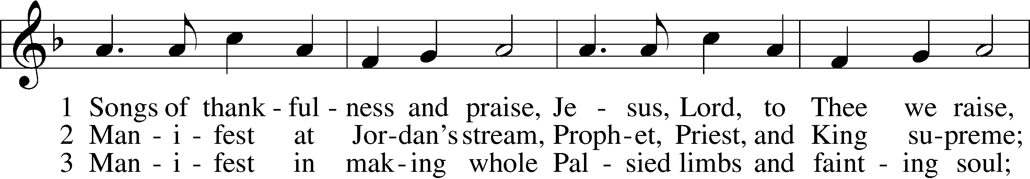
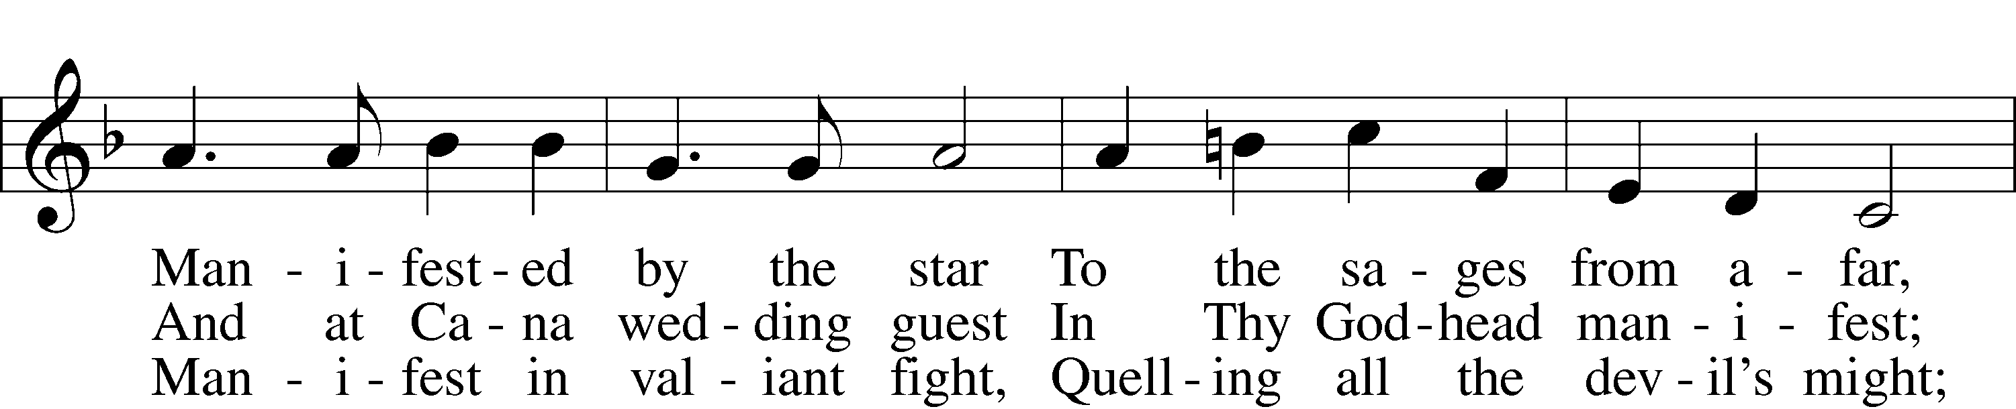
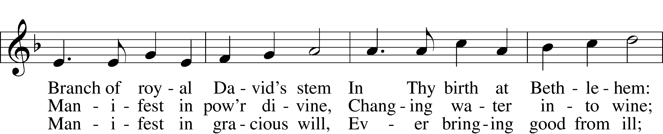
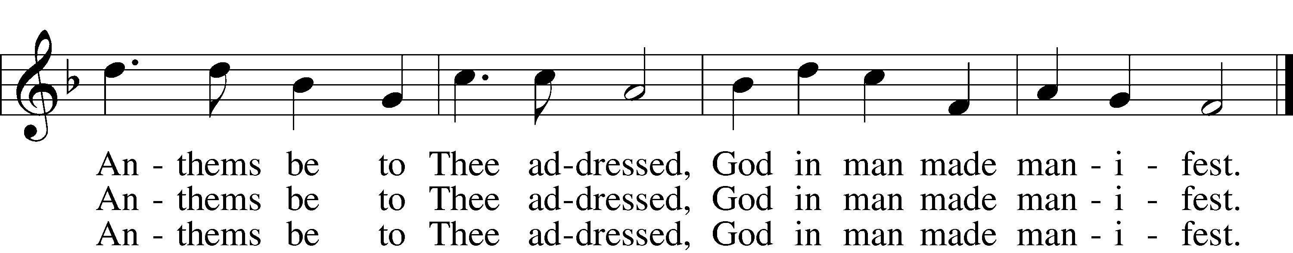
Text and tune: Public domain

Please stand as able
CONFESSION and ABSOLUTION
The sign of the cross may be made by all in remembrance of their Baptism.

P In the name of the Father and of the T Son and of the Holy Spirit.
C Amen.
P Our help is in the name of the Lord,
C who made heaven and earth.
P If You, O Lord, kept a record of sins, O Lord, who could stand?
C But with You there is forgiveness; therefore, You are feared.
P Since we are gathered to hear God’s Word, call upon Him in prayer and praise, and receive the body and blood of our Lord Jesus Christ in the fellowship of this altar, let us first consider our unworthiness and confess before God and one another that we have sinned in thought, word, and deed, and that we cannot free ourselves from our sinful condition. Together as His people let us take refuge in the infinite mercy of God, our heavenly Father, seeking His grace for the sake of Christ, and saying: God, be merciful to me, a sinner.
C Almighty God, have mercy upon us, forgive us our sins, and lead us to everlasting life. Amen.
P Almighty God, merciful Father, in Holy Baptism You declared us to be Your children and gathered us into Your one, holy Church, in which You daily and richly forgive us our sins and grant us new life through Your Spirit. Be in our midst, enliven our faith, and graciously receive our prayer and praise; through Your Son, Jesus Christ, our Lord.
C Amen.

SERVICE OF THE WORD
KYRIE LSB 204
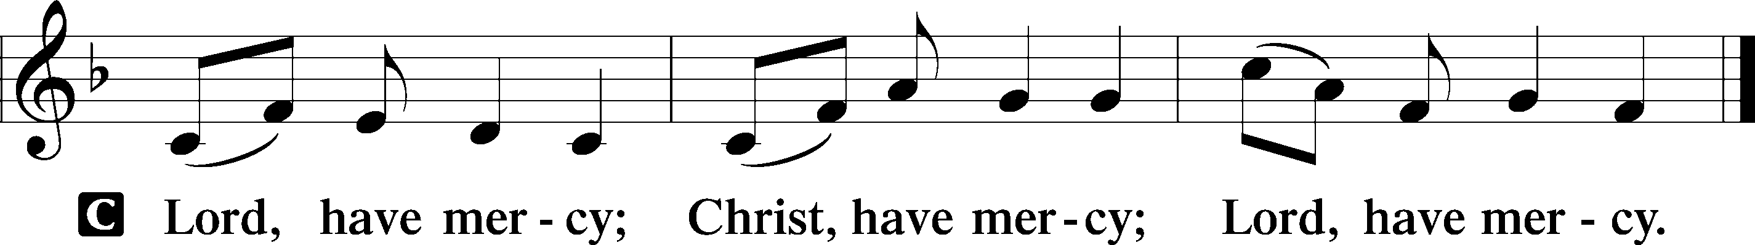

HYMN OF PRAISE
Joyful, Joyful We Adore Thee LSB 803 sts. 1, 3
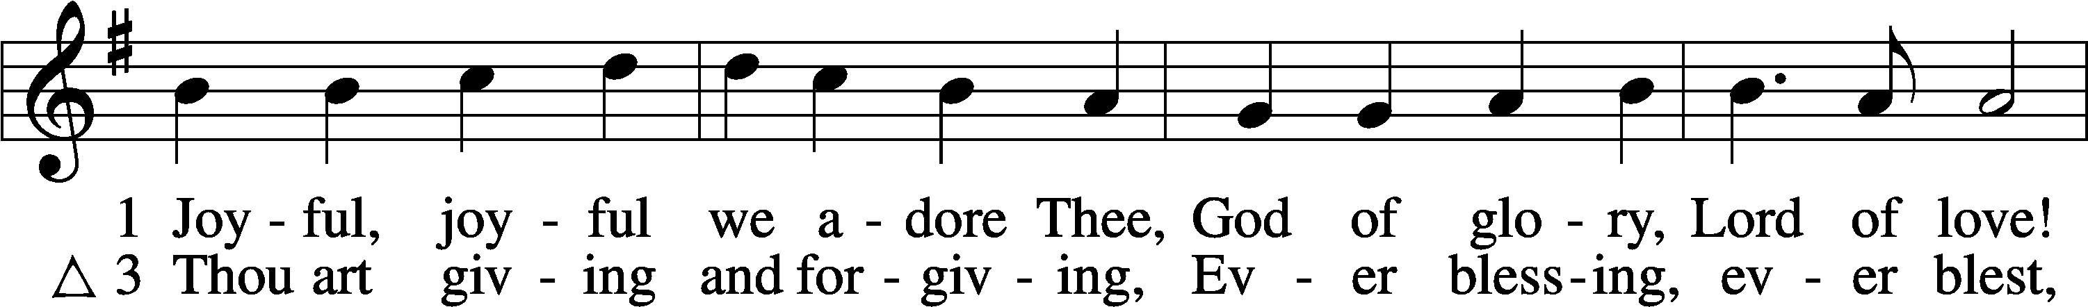
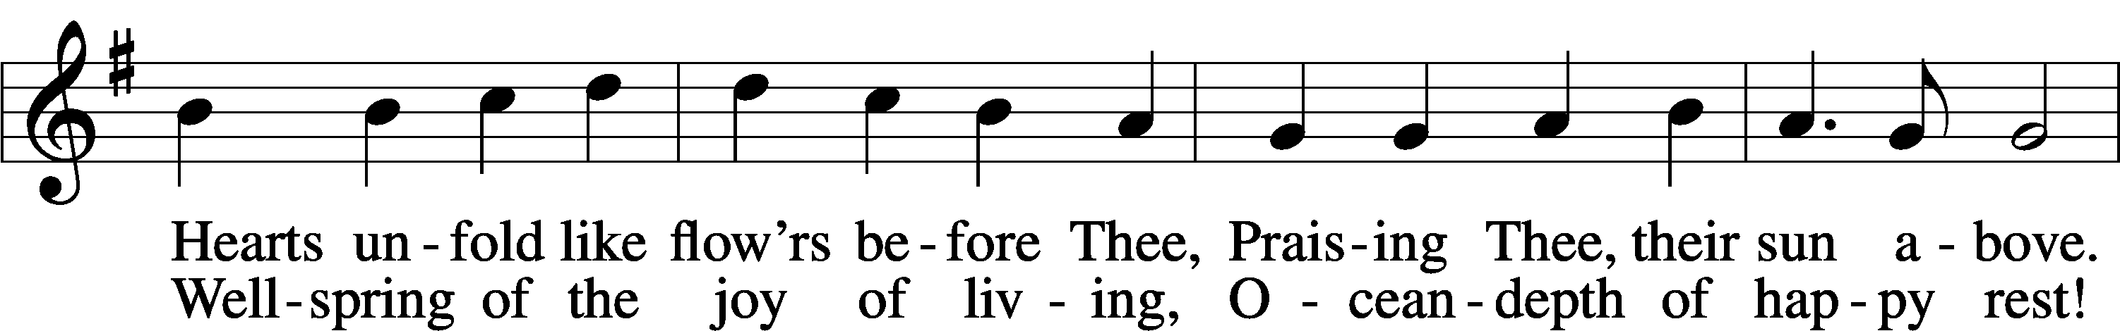
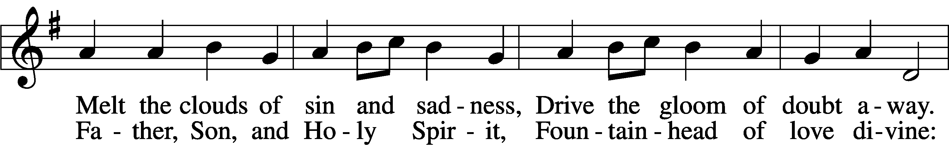
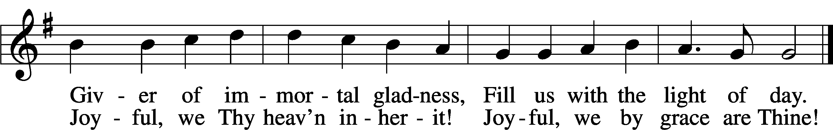
Text and tune: Public domain

SALUTATION and COLLECT of the DAY
P The Lord be with you.
C And also with you.

P Let us pray.
Father in heaven, at the Baptism of Jesus in the Jordan River You proclaimed Him Your beloved Son and anointed Him with the Holy Spirit. Make all who are baptized in His name faithful in their calling as Your children and inheritors with Him of everlasting life; through the same Jesus Christ, our Lord, who lives and reigns with You and the Holy Spirit, one God, now and forever.
C Amen.

Please be seated

OLD TESTAMENT Isaiah 43:1–7
¹But now thus says the Lord,
he who created you, O Jacob,
he who formed you, O Israel:
“Fear not, for I have redeemed you;
I have called you by name, you are mine.
²When you pass through the waters, I will be with you;
and through the rivers, they shall not overwhelm you;
when you walk through fire you shall not be burned,
and the flame shall not consume you.
³For I am the Lord your God,
the Holy One of Israel, your Savior.
I give Egypt as your ransom,
Cush and Seba in exchange for you.
⁴Because you are precious in my eyes,
and honored, and I love you,
I give men in return for you,
peoples in exchange for your life.
⁵Fear not, for I am with you;
I will bring your offspring from the east,
and from the west I will gather you.
⁶I will say to the north, Give up,
and to the south, Do not withhold;
bring my sons from afar
and my daughters from the end of the earth,
⁷everyone who is called by my name,
whom I created for my glory,
whom I formed and made.”
P This is the Word of the Lord.
C Thanks be to God.

EPISTLE Romans 6:1–11*

¹What shall we say then? Are we to continue in sin that grace may abound? ²By no means! How can we who died to sin still live in it? ³Do you not know that all of us who have been baptized into Christ Jesus were baptized into his death? ⁴We were buried therefore with him by baptism into death, in order that, just as Christ was raised from the dead by the glory of the Father, we too might walk in newness of life.
⁵For if we have been united with him in a death like his, we shall certainly be united with him in a resurrection like his. ⁶We know that our old self was crucified with him in order that the body of sin might be brought to nothing, so that we would no longer be enslaved to sin. ⁷For one who has died has been set free from sin. ⁸Now if we have died with Christ, we believe that we will also live with him. ⁹We know that Christ being raised from the dead will never die again; death no longer has dominion over him. ¹⁰For the death he died he died to sin, once for all, but the life he lives he lives to God. ¹¹So you also must consider yourselves dead to sin and alive to God in Christ Jesus.

P This is the Word of the Lord.
C Thanks be to God.

Please stand as able
ALLELUIA AND VERSE LSB 205
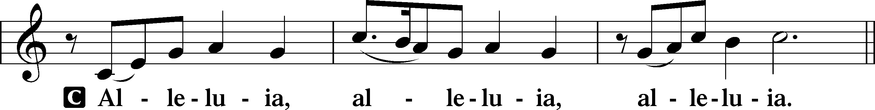

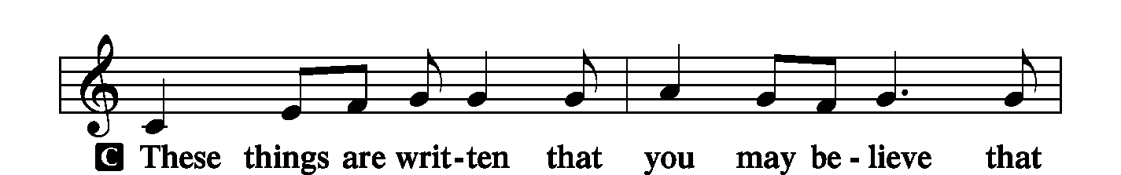
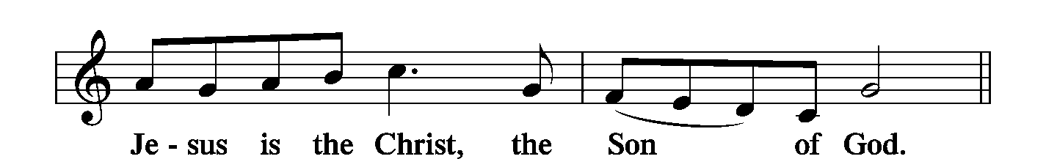
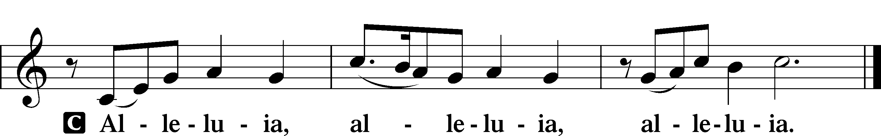

HOLY GOSPEL Matthew 3:3-17*
P The Holy Gospel according to St. Matthew, the third chapter.
C Glory to You, O Lord.

³For this is he who was spoken of by the prophet Isaiah when he said,
“The voice of one crying in the wilderness:
‘Prepare the way of the Lord;
make his paths straight.’”
⁴Now John wore a garment of camel’s hair and a leather belt around his waist, and his food was locusts and wild honey. ⁵Then Jerusalem and all Judea and all the region about the Jordan were going out to him, ⁶and they were baptized by him in the river Jordan, confessing their sins.
⁷But when he saw many of the Pharisees and Sadducees coming for baptism, he said to them, “You brood of vipers! Who warned you to flee from the wrath to come? ⁸Bear fruit in keeping with repentance. ⁹And do not presume to say to yourselves, ‘We have Abraham as our father,’ for I tell you, God is able from these stones to raise up children for Abraham. ¹⁰Even now the axe is laid to the root of the trees. Every tree therefore that does not bear good fruit is cut down and thrown into the fire.
¹¹“I baptize you with water for repentance, but he who is coming after me is mightier than I, whose sandals I am not worthy to carry. He will baptize you with the Holy Spirit and with fire. ¹²His winnowing fork is in his hand, and he will clear his threshing floor and gather his wheat into the barn, but the chaff he will burn with unquenchable fire.”
¹³Then Jesus came from Galilee to the Jordan to John, to be baptized by him. ¹⁴John would have prevented him, saying, “I need to be baptized by you, and do you come to me?” ¹⁵But Jesus answered him, “Let it be so now, for thus it is fitting for us to fulfill all righteousness.” Then he consented. ¹⁶And when Jesus was baptized, immediately he went up from the water, and behold, the heavens were opened to him, and he saw the Spirit of God descending like a dove and coming to rest on him; ¹⁷and behold, a voice from heaven said, “This is my beloved Son, with whom I am well pleased.”

P This is the Gospel of the Lord.
C Praise to You, O Christ.

NICENE CREED
C I believe in one God,
the Father Almighty,
maker of heaven and earth
and of all things visible and invisible.
And in one Lord Jesus Christ,
the only-begotten Son of God,
begotten of His Father before all worlds,
God of God, Light of Light,
very God of very God,
begotten, not made,
being of one substance with the Father,
by whom all things were made;
who for us men and for our salvation came down from heaven
and was incarnate by the Holy Spirit of the virgin Mary
and was made man;
and was crucified also for us under Pontius Pilate.
He suffered and was buried.
And the third day He rose again according to the Scriptures
and ascended into heaven
and sits at the right hand of the Father.
And He will come again with glory to judge both the living and the dead,
whose kingdom will have no end.
And I believe in the Holy Spirit,
the Lord and giver of life,
who proceeds from the Father and the Son,
who with the Father and the Son together is worshiped and glorified,
who spoke by the prophets.
And I believe in one holy Christian and apostolic Church,
I acknowledge one Baptism for the remission of sins,
and I look for the resurrection of the dead
and the life T of the world to come. Amen.

Please be seated

ALL GOD’S CHILDREN – TALK

HYMN OF THE DAY
To Jordan’s River Came Our Lord LSB 405 sts. 1–4
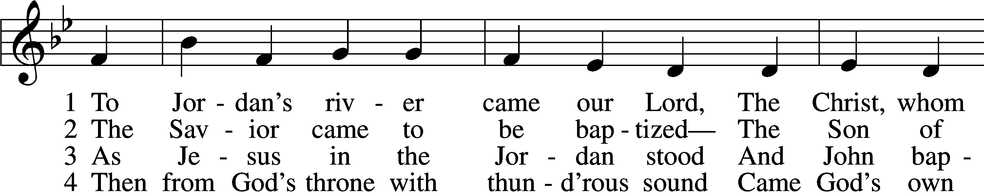
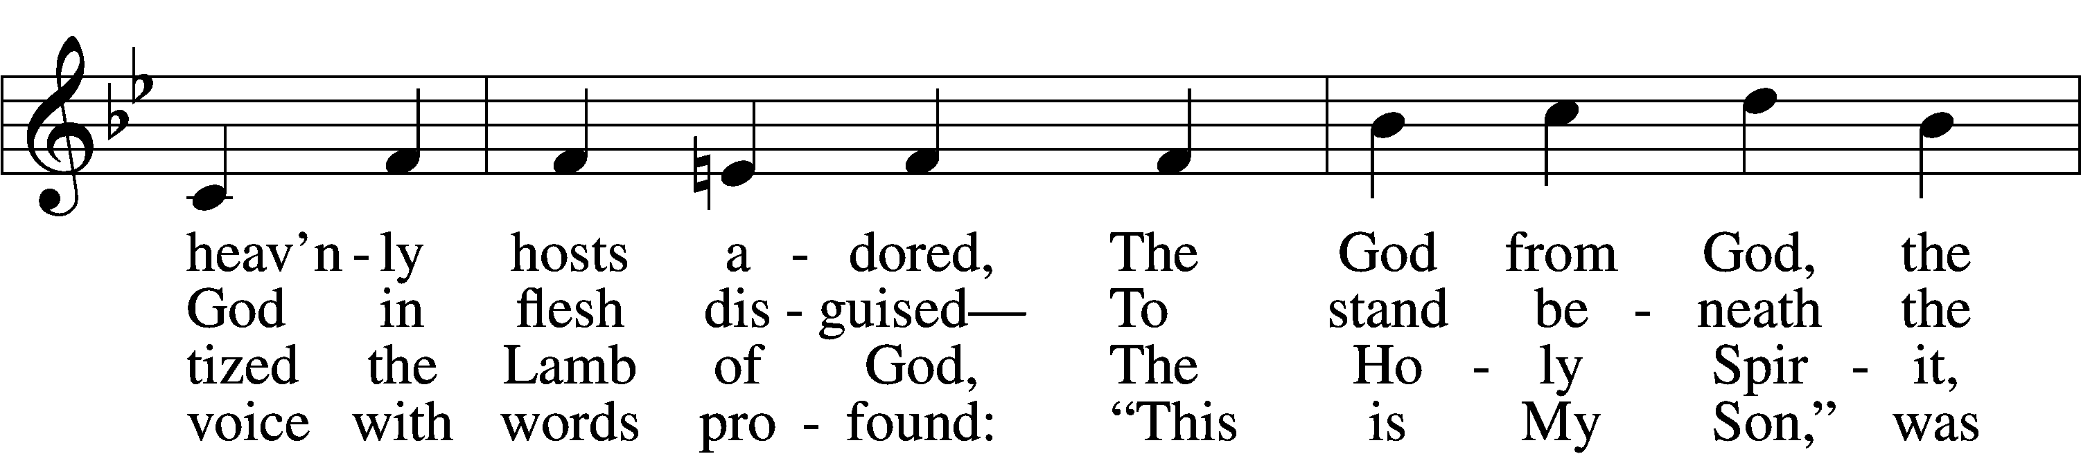
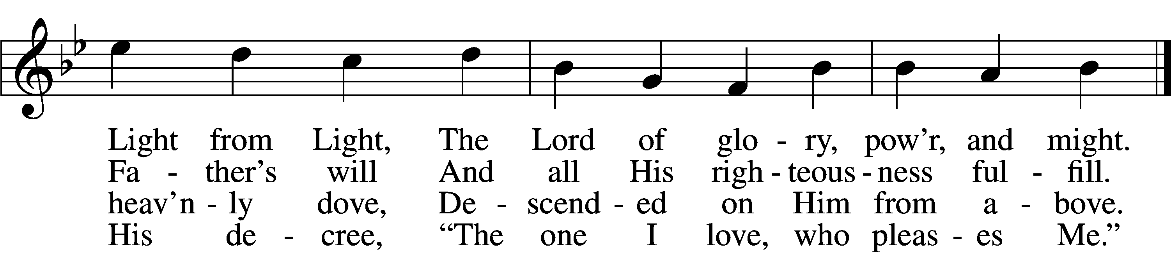

SERMON

To Jordan’s River Came Our Lord LSB 405 sts. 5–6
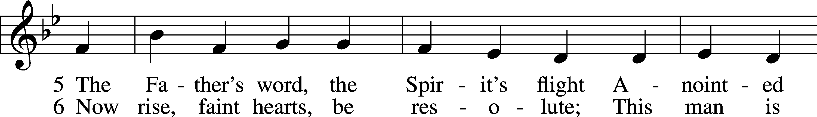
Continued on next page
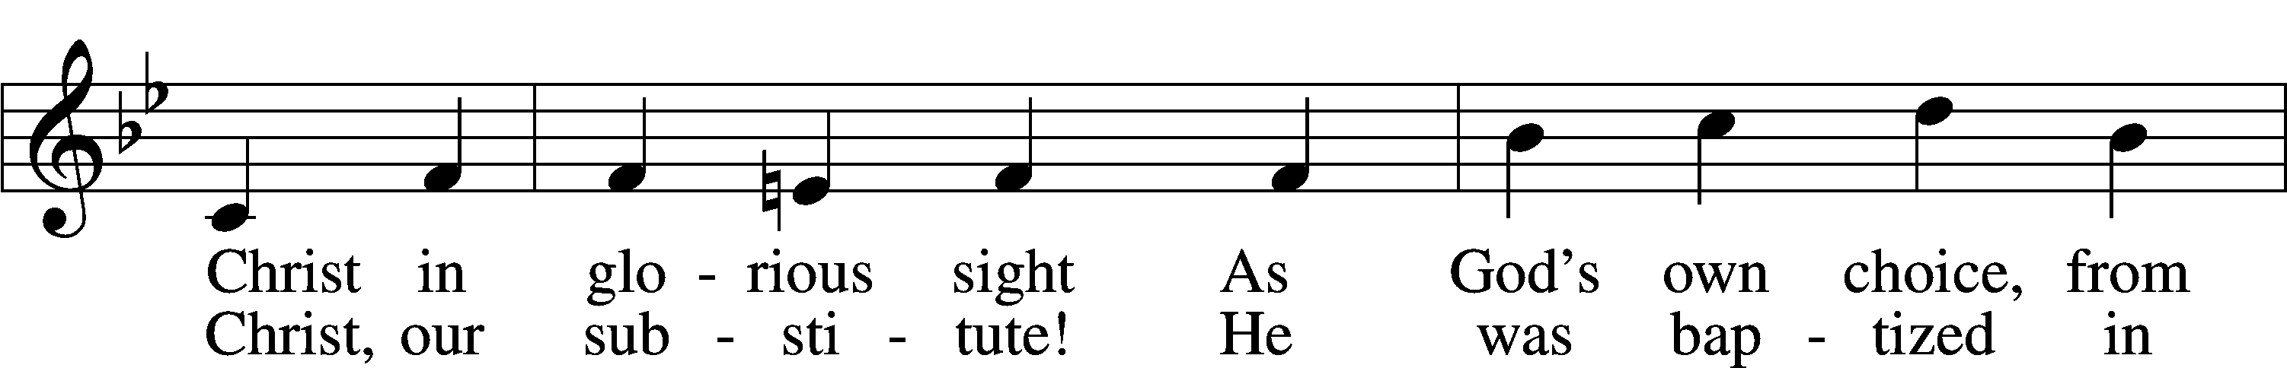
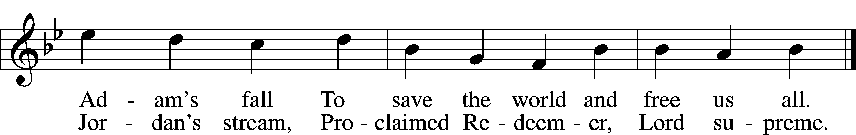
Text: © 1993 James P. Tiefel. Used by permission: LSB Hymn License no. 110002537
Tune: Public domain

Please stand as able

PRAYER of the CHURCH
After each Segment:
P Lord, in Your Mercy,
C Hear our Prayer.
After Final Segment:
P Hear us as we pray in His name and as He has taught us:

LORD’S PRAYER
C Our Father who art in heaven,
hallowed be Thy name,
Thy kingdom come,
Thy will be done on earth
as it is in heaven;
give us this day our daily bread;
and forgive us our trespasses
as we forgive those
who trespass against us;
and lead us not into temptation,
but deliver us from evil.
For Thine is the kingdom
and the power and the glory
forever and ever. Amen.

SERVICE of the SACRAMENT

PREFACE LSB 208
P The Lord be with you.
C And also with you.
P Lift up your hearts.
C We lift them to the Lord.
P Let us give thanks to the Lord our God.
C It is right to give Him thanks and praise.
P It is truly good, right, and salutary that we should at all times and in all places give thanks to You, O Lord, holy Father, almighty and everlasting God, for the countless blessings You so freely bestow on us and all creation. Above all, we give thanks for Your boundless love shown to us when You sent Your only-begotten Son, Jesus Christ, into our flesh and laid on Him our sin, giving Him into death that we might not die eternally. Because He is now risen from the dead and lives and reigns to all eternity, all who believe in Him will overcome sin and death and will rise again to new life. Therefore with angels and archangels and with all the company of heaven we laud and magnify Your glorious name, evermore praising You and singing:

SANCTUS LSB 208
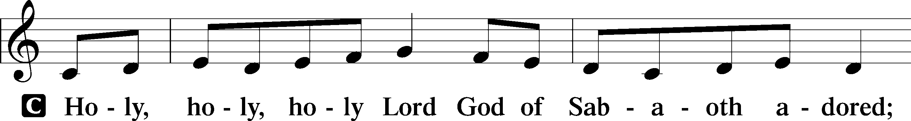
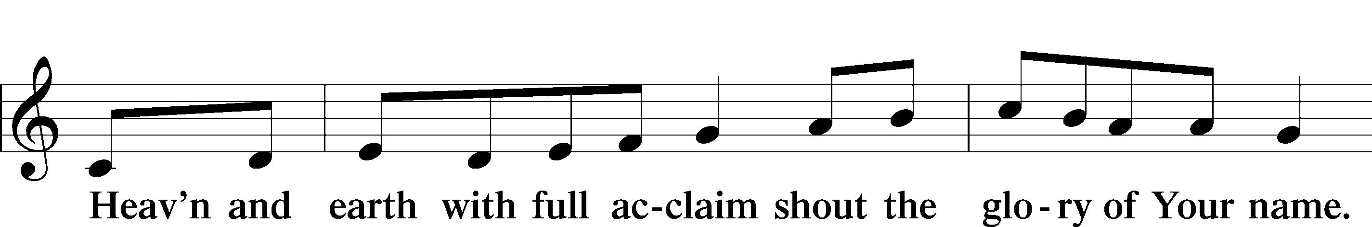
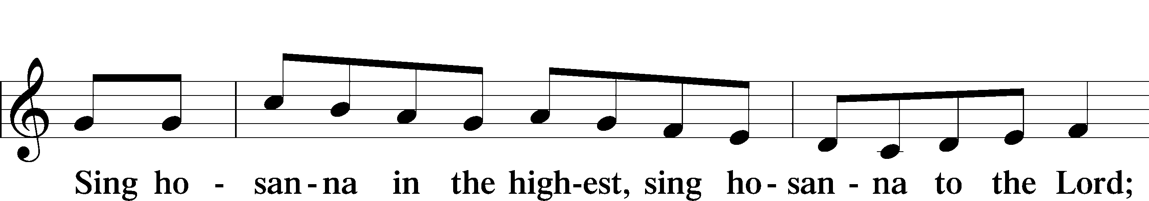

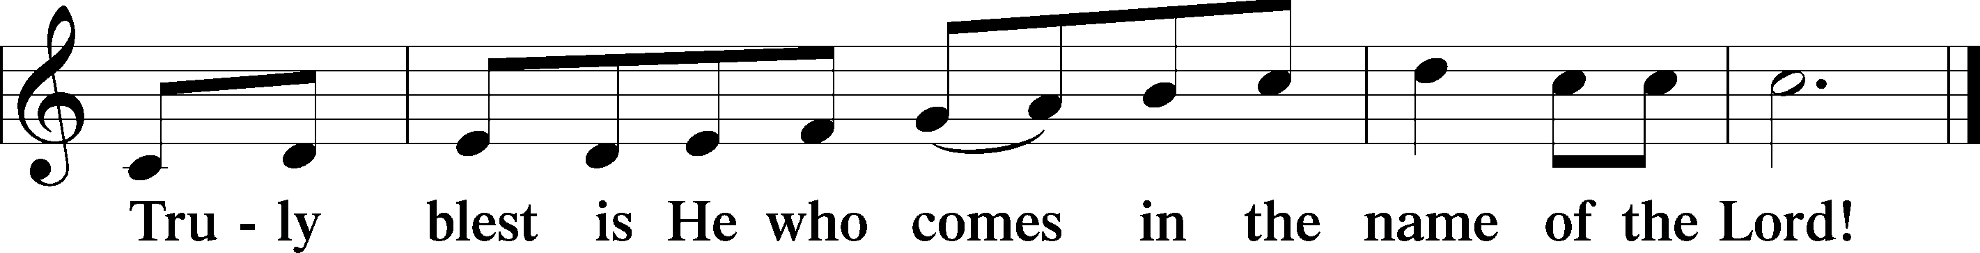
PRAYER OF THANKSGIVING
P Blessed are You, O Lord our God, king of all creation, for You have had mercy on us and given Your only-begotten Son that whoever believes in Him should not perish but have eternal life.

As the glory of Your presence once filled Your ancient temple, so in the incarnation of Your Son, Jesus Christ, You manifested the fullness of Your glory in human flesh.

We give You thanks that in His most Holy Supper You reveal Your glory to us. Grant us
faithfully to eat His body and drink His blood so that we may one day behold Your
glory face to face.

THE WORDS OF OUR LORD
P Our Lord Jesus Christ, on the night when He was betrayed, took bread, and when He had given thanks, He broke it and gave it to the disciples and said: “Take, eat; this is My T body, which is given for you. This do in remembrance of Me.”
In the same way also, He took the cup after supper, and when He had given thanks, He gave it to them, saying: “Drink of it, all of you; this cup is the New Testament in My T blood, which is shed for you for the forgiveness of sins. This do, as often as you drink it, in remembrance of Me.”

PAX DOMINI
P The peace of the Lord be with you always.
C Amen.

AGNUS DEI
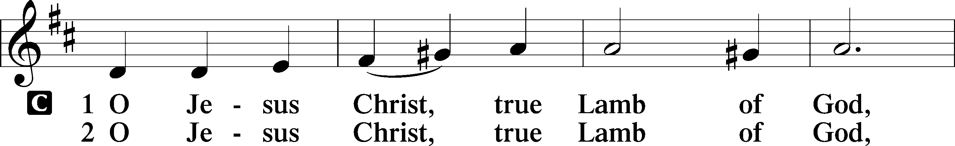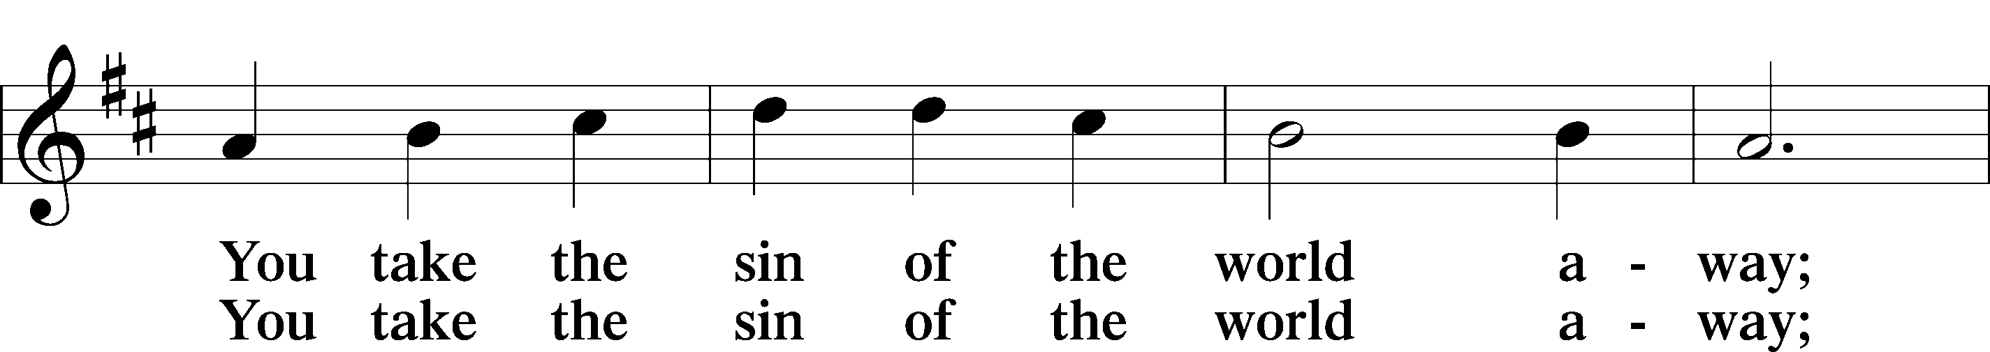
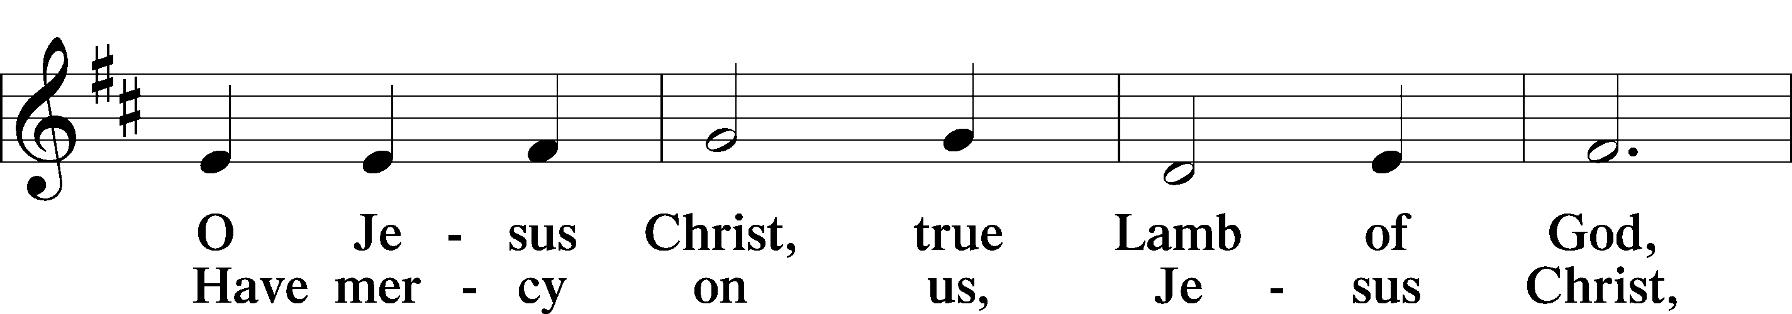
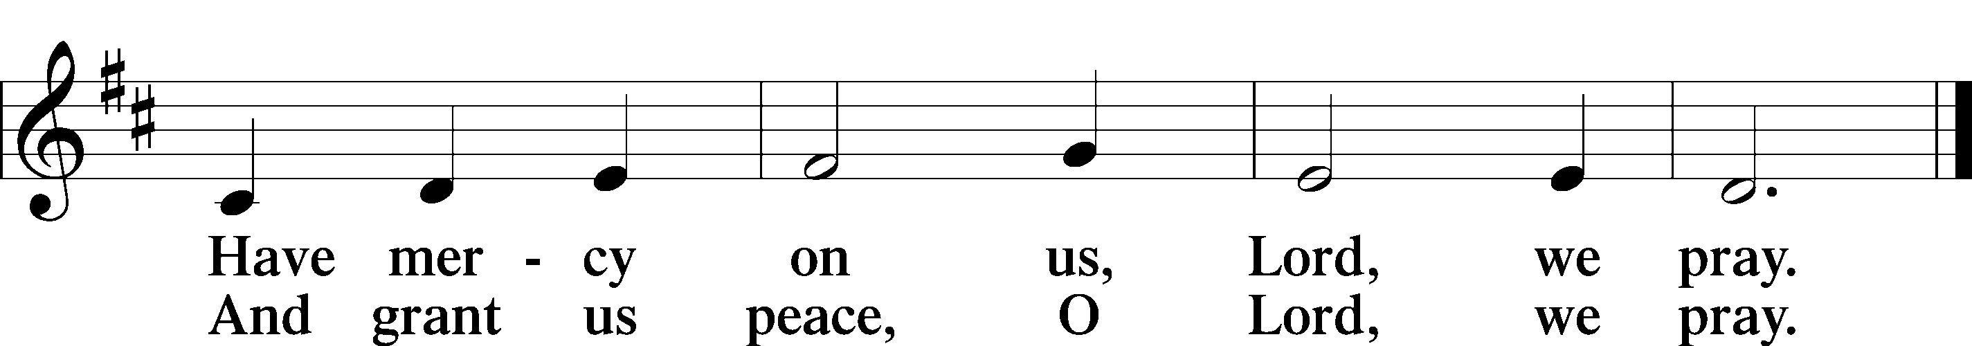

Please be seated
DISTRIBUTION
The pastor and those who assist him receive the body and blood of Christ first, then Communion will be served in a continuous fashion. Households may commune at the same time together. Ushers will help direct you forward via the center aisle; please return to your seats via the side aisles. Gluten-free bread is available for those who need it, as is non-alcoholic grape juice. Simply request either when you come forward to receive Communion.

DISTRIBUTION HYMN
Jesus, Thy Blood and Righteousness LSB 563
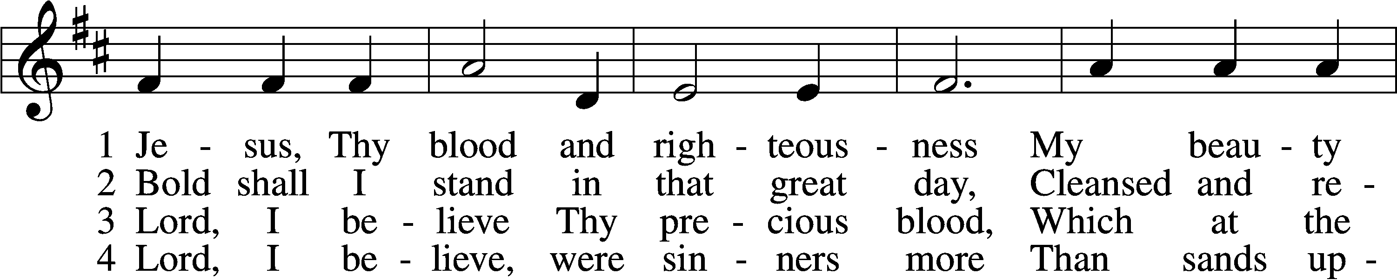
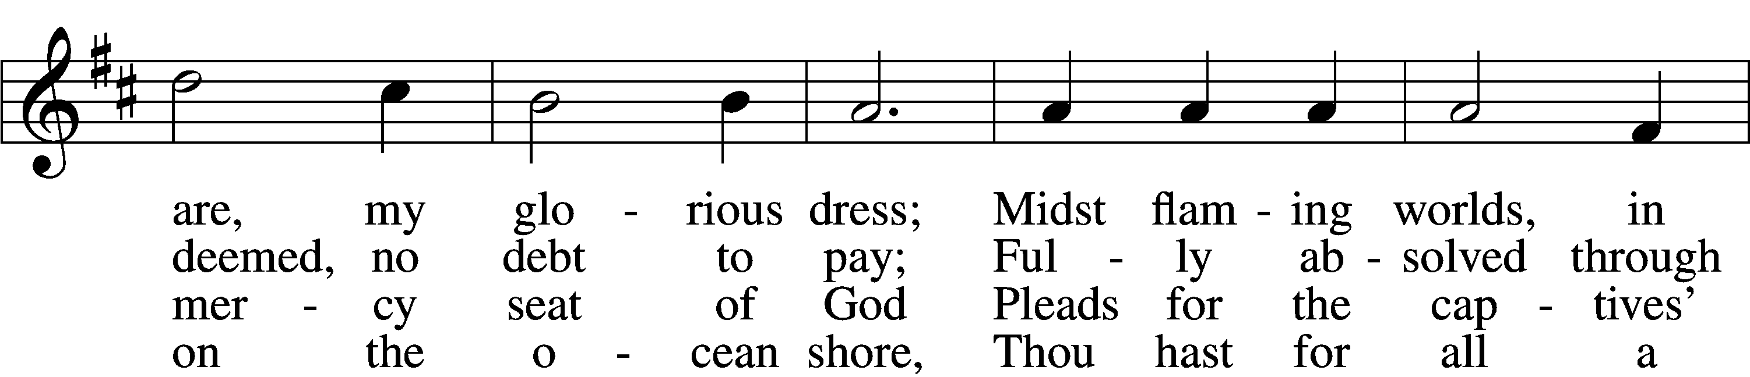
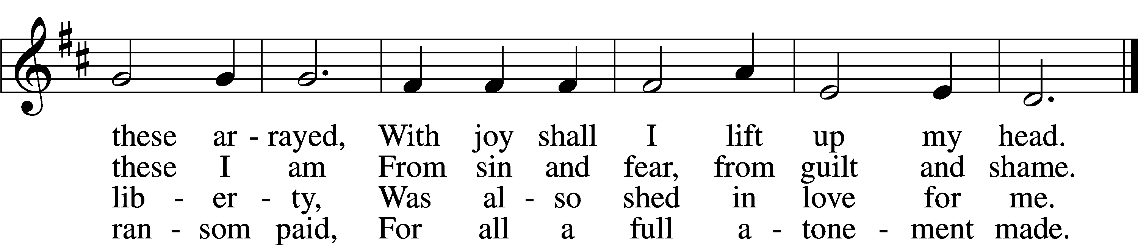
Verse 5&6 continued on next page
5 When from the dust of death I rise
To claim my mansion in the skies,
This then shall be my only plea:
Jesus hath lived and died for me.

6 Jesus, be endless praise to Thee,
Whose boundless mercy hath for me,
For me, and all Thy hands have made,
An everlasting ransom paid.
Text and tune: Public domain

THE DISMISSAL
P The body and blood of our Lord Jesus Christ strengthen and preserve you in body and soul
to life everlasting. Depart T in peace.
C Amen.

Please stand as able

NUNC DIMITTIS LSB 211
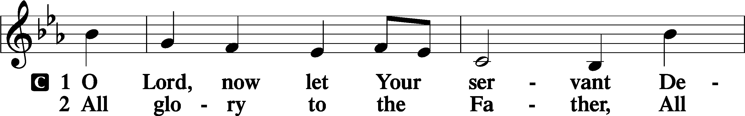
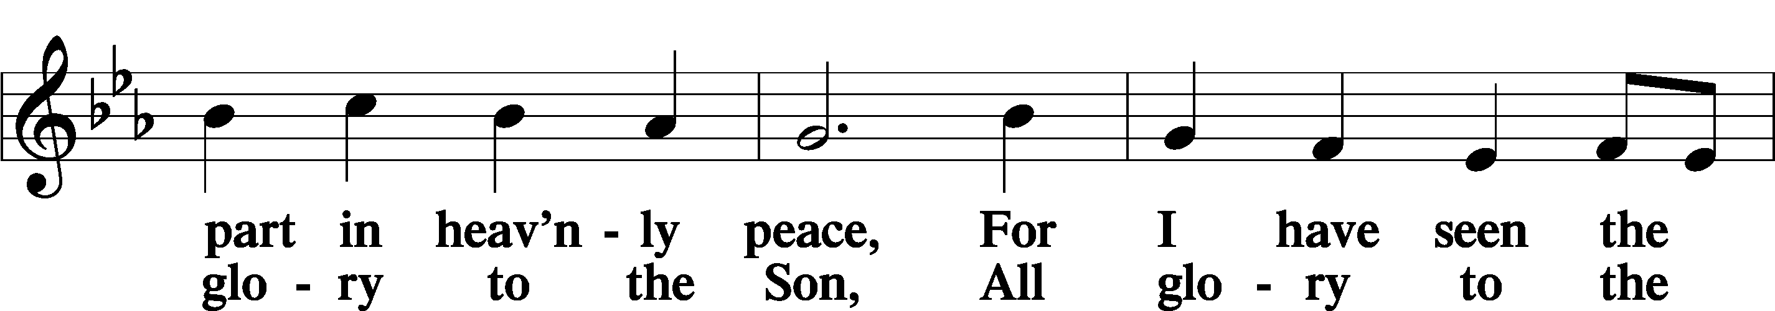
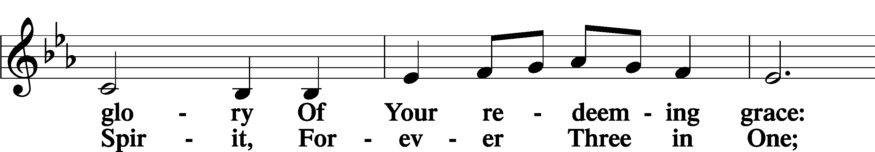
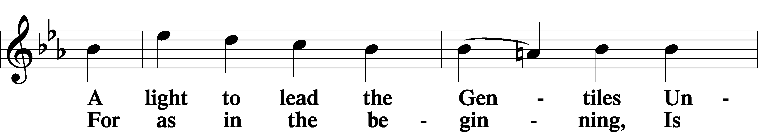
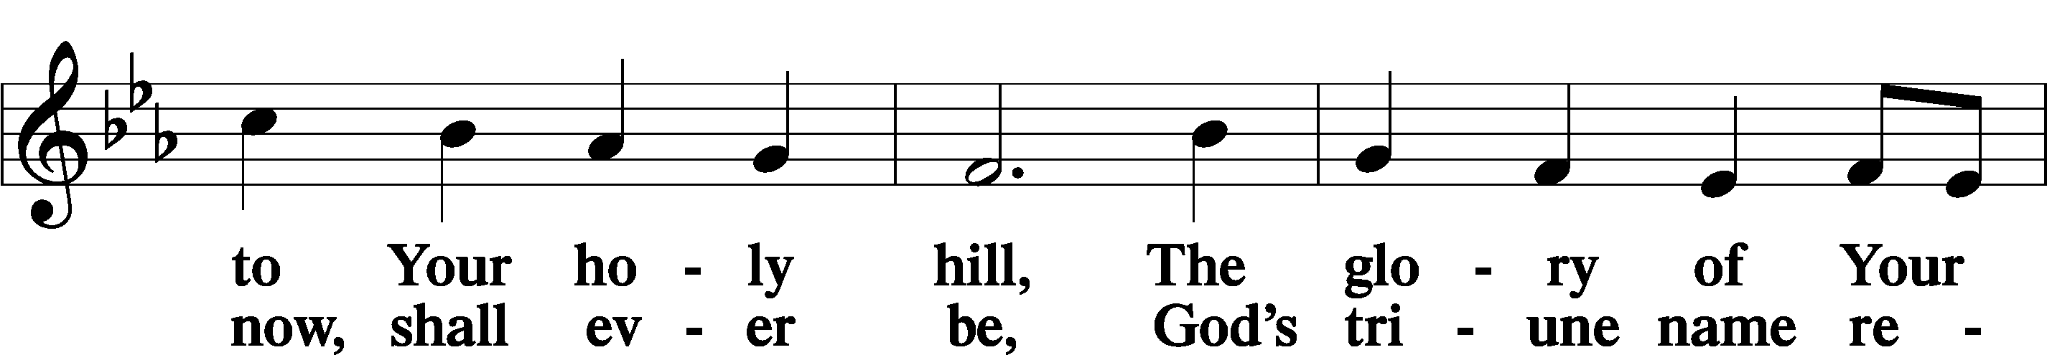
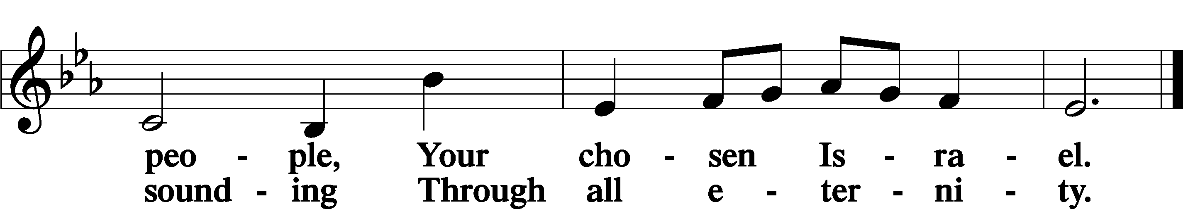

POST COMMUNION COLLECT
P Let us pray.
O God the Father, the fountain and source of all goodness, who in loving-kindness sent Your only-begotten Son into the flesh, we thank You that for His sake You have given us pardon and peace in this Sacrament, and we ask You not to forsake Your children but always to rule our hearts and minds by Your Holy Spirit that we may be enabled constantly to serve You; through Jesus Christ, Your Son, our Lord, who lives and reigns with You and the Holy Spirit, one God, now and forever.
C Amen.

BENEDICAMUS LSB 212
P Let us bless the Lord.
C Thanks be to God.
BENEDICTION
P The Lord bless you and keep you.
The Lord make His face shine on you and be gracious to you.
The Lord look upon you with favor and T give you peace.
C Amen.

Please be seated

CLOSING HYMN
Songs of Thankfulness and Praise LSB 394 sts. 4–5
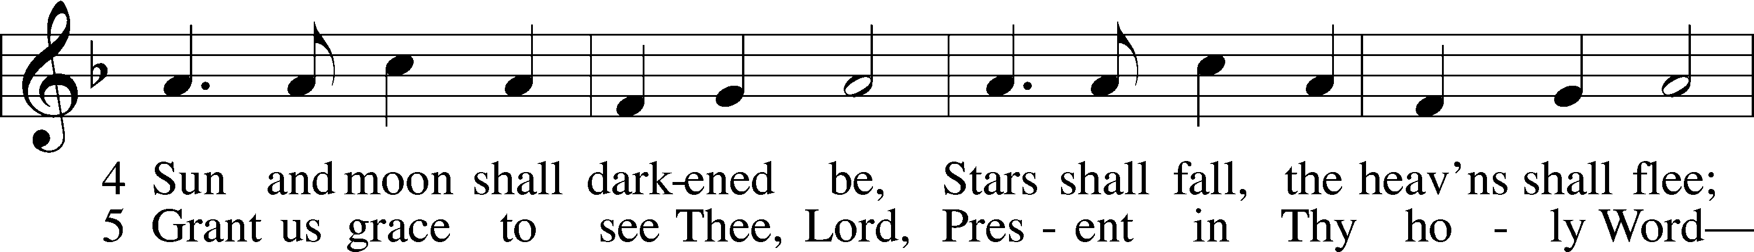
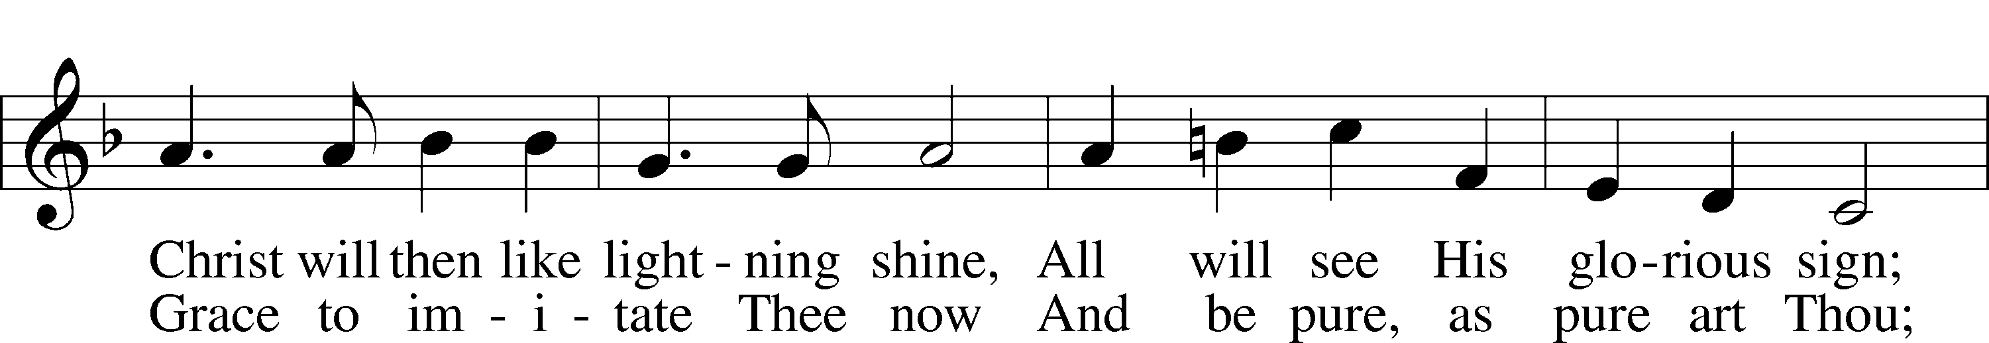
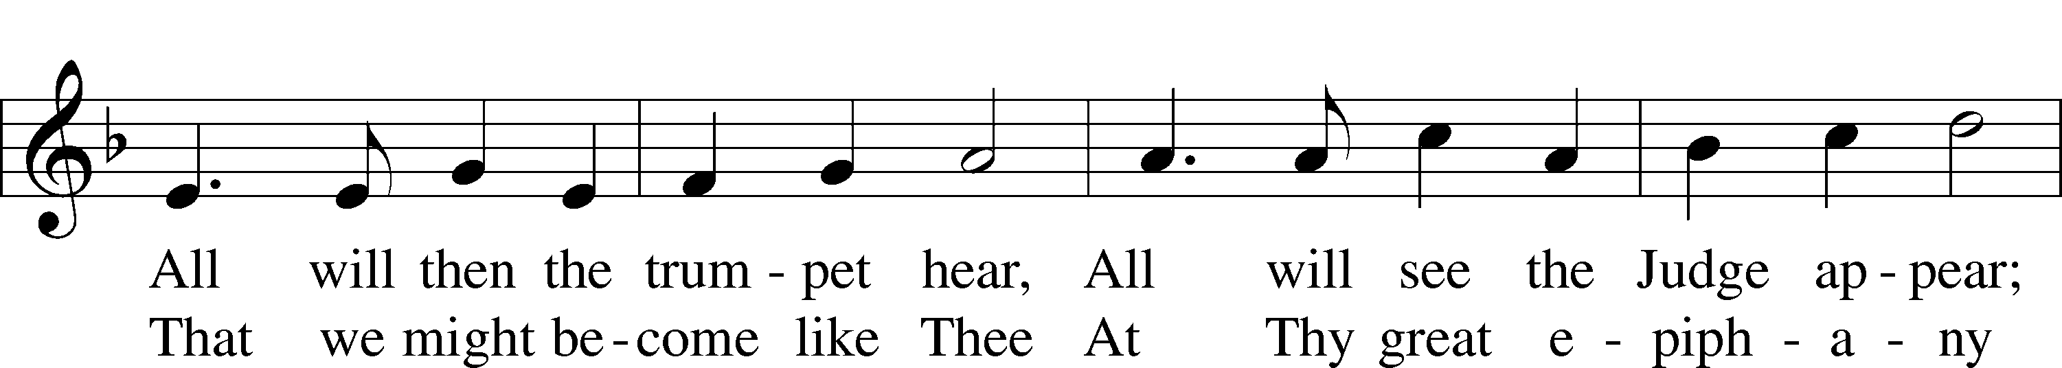
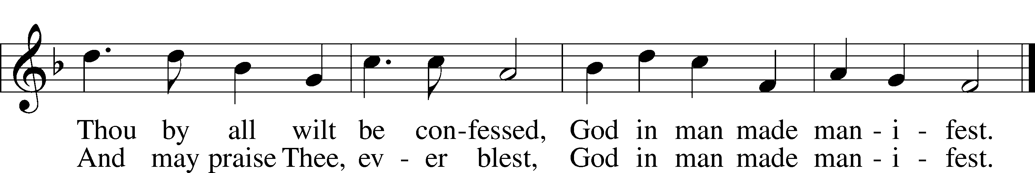
Text and tune: Public domain

ANNOUNCEMENTS and SENDING WORDS
P We go to live for Jesus!
C We go to share His love!

Acknowledgments
Unless otherwise indicated, Scripture quotations are from the ESV® Bible (The Holy Bible, English Standard Version®), copyright © 2001 by Crossway, a publishing ministry of Good News Publishers. Used by permission. All rights reserved. Created by Lutheran Service Builde

Next Week’s Readings
Old Testament: Isaiah 62:1-5
Epistle: 1 Corinthians 12:1-11
Holy Gospel: John 2:1-11

SERVING in GODS HOUSE TODAY
Pastor: Rev. Paul Schneider
Elder: Ken Mertz
Ushers: Rich & Risa Sherman
Greeters: Roger & Elaine Raschke
Coffee Servers: LWML
Counters: Donna Cottrell, Janet Arner
Altar Care: Judi Stutzman
Organ/Piano: Tom & Jean Beach
Children’s Talk: Nancy Ely

PRAYERS
Please contact the office with updates to the prayer list. People will remain on the prayer list for 4 weeks before being removed. If they need to remain on the list, please keep Elaine informed and of any updates. This will help us to have a more accurate list. Thanks for your cooperation.

REMEMBER IN YOUR PRAYERS
Those who continue to grieve the passing of loved ones, Family of Bob Breen, Family of Deb Borowiak, Family of Angie Ward, and Family of Peggy Scheedig.
Those with upcoming surgery:
Those recovering from surgery: Elaine Foley, and Jennifer Martin.
Those with health concerns: Tiffany Amsdill, Amy and Jim, Laurie Breen, Hope Buchinger, Karen Christoff, Bridget Cook, Vi Erat, Brenda Hart, Robert Lincoln , Leslie Martin, Eleanor Raether, Beth Smith, Rod Taylor, and Lyle Yingling.
Those diagnosed with cancer: Leah Eicher, Rachel Frisch, Joe Gibson, Hope Osantowski
Those under Hospice Home Care: Ruth Luebs, and Ken Williamson.

BIRTHDAYS: ANNIVERSARIES;
Jim Kunisch None
Brady Beyers
Abbie Trahin

MESSAGES
ALTAR FLOWERS placed last week were placed to the glory of God by Del Krueger.
Altar Flowers placed this week are placed to the glory of God by Brian and Tami Techle for January birthdays.

MEMBER & GUEST CARDS: If you have not filled out a member/guest card, please take the time to fill one out and place it in the plate behind the back pews in our sanctuary.

WEDNESDAY MORNING BIBLE STUDY, 10:00am in the fellowship hall with Pastor Ken Bernthal.

GREETING CARDS If you are in need of some greeting cards, we carry an array of them in the cabinet in the library. The cost of the cards is posted on the cabinet. The money collected from the cards goes to LWML to help support Missions.

CANCER and FRIENDS SUPPORT GROUP: Will be meeting in January 25th... We will be having a guest speaker from OCCOA. Please remember Cancer & Friends Support Group is not just for people going through treatment, or survivors, we are also here for caregiver, spouse, children, and friends. There are times when we can all use someone to talk to during those difficult times. If there is any subject you would like to discuss with me you call or text or at 989-350-4391. Hope you will join us.

YOUNG WOMAN’S SUNDAY: Today, we will be celebrating Young Woman’s Sunday. We have invited all the younger women in our congregation, those who are in college, starting careers, raising children and are otherwise filled with the pressures of being a younger woman today. Jacki Parmer, Michigan’s Young Women Representative to the LWML National Convention in Lexington in 2021, will be speaking after the service in the fellowship hall to share her experience at the convention and the challenges of being a young woman in the church today. Jacki is a Christian wife, mother of two active children and a hospice RN. Everyone is welcome to listen in, and will enjoy Jacki’s talk. LWML and Ladies Guild will be serving a brunch after the service, to which all are invited. Help us encourage our younger women in their faith and membership in our church body.
LWML NEWSLETTER If you have not already received your newsletter they are in the rack above the shelf in the narthex. If you took a copy of Trinity’s newsletter one should be attached to the back of that newsletter.
CRAFT DAY Coming sometime in March. We will be putting up a sign-up sheet as soon as we get the date for March.
KUT-UPS will be meeting Monday January 10th at 10am in the fellowship hall.

BACK HALLWAY: If you had anything on the coat racks or floor in the back hallway it has been taken down stairs and put on a table. If it is for a group you teach or are in charge of, please put it in its proper place either in the room on downstairs, there are shelfs to use just label the shelf you use.
CONGREGATIONAL MEETING: The Congregational Annual Report meeting will be held on February 6, 2022 after the church service. Please mark this date on your calendar.

THIS WEEK AT TRINITY
January 9 Sunday
9:00 am Worship Service - Holy Communion – Rev. Paul Schneider
10:15 am Fellowship & Coffee Hour
10:30 am Young Woman’s Sunday, W/ Brunch
January 10 Monday
10:00 am Kut-Ups (Fellowship Hall)
7:00 pm Choir
January 11 Tuesday
6:30 pm Church Council Meeting (Fellowship Hall)
January 12 Wednesday
10:00 am Wednesday Morning Bible Study W/ Pastor Ken Bernthal
January 13 Thursday
1:00 pm Ladies Guild (Library)
7:00 pm Erat’s Home Bible Study
January 14 Friday
January 15 Saturday
January 16 Sunday
9:00 am Worship Service - Holy Communion – Rev. Paul Schneider
10:15 am Fellowship & Coffee Hour
10:30 am Bible Study with Dr. Tom Beach (Tutoring Room)

